Wisteria Farm IEA Equestrian Team
About IEA: For student equestrians in grades 6-12, the Interscholastic Equestrian Association (IEA) was established in the spring of 2002. IEA has over 8,000 members in 32 states across North America. There is no need for any rider to own a horse because competition horses are provided at each venue to the contestant. The MISSION of the IEA is to introduce students in private and public middle and secondary schools to equestrian sports and to promote and improve the quality of equestrian competition and instruction. To fulfill its purpose, the IEA offers guidance regarding the creation and development of school and/or barn associated equestrian programs. IEA coaches aim to develop understanding and appreciation of equestrian sports through organized student competitions and additional equine educational opportunities. Students have the opportunity to earn scholarships toward their college education through awards in competition and through sportsmanship activities. www.rideiea.org

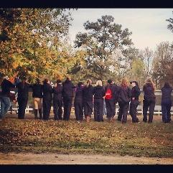
IEA Competition Format: The unique aspect of the competitions, both at the local and national level, is that none of the riders will supply their own horses or tack. Instead, the host team arranges for the horses and equipment. Since the horse is new to the rider, the scores are based upon horsemanship and equitation. All disciplines offer a variety of ability levels from beginner through advanced. The IEA has set guidelines for the placement of new riders entering the IEA to allow for the unique program format of riding an unfamiliar horse. The IEA is an affiliate of the National Reining Horse Association (NRHA), the United States Equestrian Federation (USEF), the United States Hunter Jumper Association (USHJA) and the Intercollegiate Horse Show Association (IHSA).
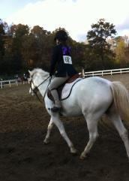
Wisteria Farm’s IEA Team practices start in August!!! Please visit www.wisteriafarms.com or call 781-249-8717
Monroe, Ga.

